PROJECT REPORT
Big Data Analytics and DBMS

TELCO CUSTOMER
CHURN ANALYSIS
An Individual End-to-End Big Data Analytics and Business Intelligence Project
Using PostgreSQL, SQL Shell(psql), DBeaver, Python, Databricks/Spark, Delta Lake and Power BI

Student name | Khush Talera
Roll number | 25018
Submitted to | Dr. Butchi Babu Muvva (Faculty)
Dataset | telco.csv (7,043 customers, 21 fields)
Submission date | 29 October 2026
Institution: Badruka School Of Management, Hyderabad
Individual academic project report
Table of Contents
1. Acknowledgement and declaration 3
2. Abstract / executive summary 4
3. Introduction and business problem: context 4
4. Introduction and business problem: statement 5
5. Objectives, scope and limitations 6
6. Dataset and data dictionary: overview 7
7. Dataset and data dictionary: fields 7
8. Methodology and workflow 9
9. PostgreSQL and DBeaver: database design 10
10. PostgreSQL and DBeaver: loading and validation 11
11. SQL implementation: churn by contract 12
12. SQL implementation: internet and payment 12
13. SQL implementation: tenure and tech support 13
14. Python analytics: profiling 14
15. Python analytics: cleaning and descriptive statistics 15
16. Python analytics: chart 1 16
17. Python analytics: chart 2 17
18. Python analytics: chart 3 18
19. Databricks and Delta Lake: architecture 18
20. Databricks: processing steps and outputs 19
21. Power BI dashboard and insights: design 21
22. Power BI: measures and visual interpretation 22
23. Power BI: business insights 23
24. Integration and validation 24
25. Results and discussion: overall 25
26. Results and discussion: business implications 26
27. Recommendations and implementation roadmap 26
28. Conclusion, future improvements and individual contribution 28
29. References and supporting evidence: references 30
30. Supporting evidence and appendix 31

Acknowledgement and declaration

Acknowledgement
The author expresses sincere gratitude to Dr. Butchi Babu Muvva for his academic guidance and supervision throughout this course and project. The guidance that every figure, table and screenshot should be accompanied by clear commentary and an honest statement of limitations has been followed throughout this report. The author also acknowledges the publicly available documentation for PostgreSQL, Apache Spark, Databricks and Power BI, which was consulted while completing the technical work.

Declaration
I, Khush Talera (Roll No. 25018), declare that this report is the result of my own individual work. The dataset was supplied as a project input, external sources are listed in the References section, and no result in this report has been presented as stronger than the supplied evidence supports. In particular, no trained machine-learning model or measured retention experiment is claimed.
Student signature: Khush Talera Date: 29-10-2026

Scope of the report
This report documents the descriptive analysis of a supplied telecom churn snapshot using SQL, Python, Spark and Power BI workflows. It does not report a trained predictive model, a causal estimate or a live retention campaign.

Report at a glance
Item | Detail
Dataset | telco.csv, one row per telecom customer
Records and fields | 7,043 customers; 21 fields
Churned customers | 1,869 (26.54%)
Retained customers | 5,174 (73.46%)
Average monthly charges | $64.76
Average tenure | 32.4 months
Tools used | PostgreSQL, psql, DBeaver, Python, Spark, Databricks, Power BI
Type of analysis | Descriptive and diagnostic; no predictive model reported

Abstract / executive summary

Executive summary
This project analyses 7,043 telecom customer records to understand customer churn, describe customer segments associated with leaving, and translate findings into practical retention actions. The supplied dataset contains 21 fields spanning customer attributes, service subscriptions, contract and payment details, charges, tenure and the churn outcome.
The observed churn outcome is 1,869 customers (26.54%), while 5,174 customers (73.46%) stayed. Average monthly charges are $64.76, and average tenure is 32.4 months.
The implemented workflow uses CSV as the source, PostgreSQL as a relational store, SQL Shell for loading, DBeaver for SQL analysis, Python/pandas for profiling and cleaning, Spark in the supplied notebook for distributed-style transformations, Databricks for a cloud dashboard, and Power BI for interactive reporting.
The strongest observed associations are higher churn among month-to-month contracts, first-year customers, fiber-optic customers, electronic-check payers, and customers without tech support. These are descriptive associations, not proof of causation.
Important scope note: the supplied notebook contains profiling, cleaning and segment analysis, but no trained or evaluated predictive machine-learning model. A prediction model is proposed as future work rather than reported as completed.

Detailed explanation and project context
Churn is a useful outcome because it is concrete and relevant to both revenue and customer experience. However, a churn label alone does not explain the customer’s reason for leaving. The analytical task is therefore divided into three stages: first establish a reliable baseline, then compare the outcome across meaningful groups, and finally formulate actions that can be tested. The baseline is important because an organisation needs a common reference point before judging whether a retention programme has improved results. Segment comparisons are diagnostic: they reveal where churn is more common, but they do not prove that a particular attribute caused the outcome. Additional evidence, such as complaint history, network incidents, price changes and customer interviews, would be required to establish likely mechanisms.

Introduction and business problem: context

1. Introduction
Telecommunications businesses operate in competitive markets where customers can change providers, plans or service bundles. Losing customers can reduce recurring revenue and increase the cost of replacing them. Customer churn analysis helps an organisation understand where customer losses are concentrated and where retention efforts may be worth testing.
The project treats churn as a business analytics problem. The data records whether a customer left, alongside service usage choices, account characteristics, contract type, payment method, monthly charges and tenure. These variables enable comparisons between customer groups.

Business context
A useful churn programme does not assume that every customer has the same reason for leaving. Customers may differ in contract flexibility, service experience, support needs, billing preferences and relationship maturity. Segment-level analysis provides a first diagnostic view before customer interviews, operational data or controlled experiments are added.

Detailed explanation and project context
The business question can be translated into operational decisions. Marketing may use the analysis to decide which customer groups should receive tailored communications; service operations may investigate whether a product category has recurring quality issues; billing teams may inspect payment journeys; and customer-support teams may improve awareness of available help. The analysis does not recommend contacting every customer in a high-churn segment automatically. Any action should consider eligibility, consent, profitability and the risk of offering discounts to customers who would have remained anyway. The preferred next step is a small, measurable pilot with a comparison group. This converts descriptive evidence into a learning process while limiting unnecessary cost and customer disruption.

Introduction and business problem: statement

1.1 Problem statement
The business problem is: how can a telecom provider use customer, service and billing data to identify customer groups with comparatively high churn and prioritise practical retention interventions?

Why the problem matters
- Churn affects recurring revenue and customer lifetime value.
- Acquisition campaigns may be less efficient if avoidable churn remains high.
- Retention teams need evidence to prioritise segments rather than treating all customers equally.
- A repeatable data pipeline makes results easier to refresh and audit.

Intended users
The intended users are marketing managers, customer-retention teams, customer experience leaders, service operations, billing teams and analysts. They can use the findings to formulate retention hypotheses, design campaigns and monitor whether later interventions improve outcomes.
This report is descriptive and decision-support oriented. It identifies patterns in the supplied snapshot; it does not establish why an individual customer left.

Detailed explanation and project context
The scope is deliberately bounded by the fields and artefacts supplied. The file provides a customer snapshot with demographic indicators, subscriptions, contract, payment method, tenure, charges and a churn label. It does not include a date for each event, a timeline of plan changes, detailed network performance, complaint text or campaign exposure. Consequently, the project can report segment rates and summary statistics, but cannot reliably establish the sequence of events that preceded churn. The analysis also does not demonstrate a trained machine-learning model or a measured retention experiment. These are stated as future improvements, not hidden omissions. This transparent scope makes the results easier for a faculty reviewer to assess and reproduce.

Objectives, scope and limitations

2. Objectives
- Profile the dataset and check data quality.
- Load the source data into PostgreSQL and analyse it using SQL.
- Clean text fields and convert TotalCharges into a numeric field for analysis.
- Calculate overall churn and compare churn across contract, internet service, payment method, tenure and tech-support segments.
- Use Spark/Databricks workflow elements and document the dashboard structure.
- Present findings through readable visuals and translate them into practical retention recommendations.

Scope
The analysis covers the 7,043-row, 21-column telco dataset supplied as telco.csv. The report documents the provided SQL scripts, Python notebook, PowerPoint evidence and Databricks dashboard JSON. The published Databricks dashboard URL was supplied by the student.

Limitations and assumptions
- The data is a single snapshot; no event history or time series was supplied.
- Segment comparisons are univariate and do not control for confounding variables.
- The dataset does not include customer complaints, network outages, competitor offers or stated reasons for leaving.
- The supplied code does not train or evaluate a churn prediction model.
- The supplied dashboard configuration includes KPI and segment-count visuals; not every chart is a churn-rate chart.

Detailed explanation and project context
A reliable data dictionary supports consistent interpretation across SQL, Python, Spark and dashboards. The identifier customerID is useful for row-level checks but should normally be excluded from predictive features because it is an arbitrary identifier rather than a customer behaviour. The binary SeniorCitizen field is encoded numerically as 0 or 1. Many service fields use values such as Yes, No and No internet service; these are categories, not interchangeable numeric values. The charge columns are numeric measures, while tenure is a count of months. The outcome field Churn is categorical. Maintaining these distinctions prevents invalid averages and makes transformations explicit. Field definitions should be kept beside the code so that future updates do not silently change the meaning of a metric.

Dataset and data dictionary: overview

3. Dataset overview
The source file telco.csv contains 7,043 records and 21 columns. Each row represents one customer.
The outcome variable is Churn: “Yes” indicates the customer left and “No” indicates the customer stayed. CustomerID is an identifier and should not be treated as a predictive signal in a future model.

Data collection and provenance
The file was provided as a project input. The report treats it as a supplied telecom customer churn dataset. The project files indicate it was loaded into PostgreSQL and Databricks. No claim is made that the records were generated by the student or collected directly from a live telecom operator.

Data-quality observations
The raw CSV contains 11 values in TotalCharges that cannot be parsed as numeric (blank strings in the source). Pandas does not initially interpret these blanks as missing until the column is converted using to_numeric(errors='coerce'). The dataset has 0 exact duplicate rows by full-row comparison.

Detailed explanation and project context
The data-quality review shows why data types should be checked rather than accepted blindly. TotalCharges is initially read as text because blank entries occur in the source. A numeric conversion with coercion exposes these entries as missing values. This is preferable to treating an empty string as a numeric zero, which would incorrectly imply that the customer accumulated no charges. The raw file has no exact duplicate full rows, but this does not by itself prove that every business key is unique; a separate customerID uniqueness check is appropriate. Cleaning should be repeatable and should preserve the raw file unchanged. Any excluded rows should be documented along with the reason and the analytical tasks affected by the exclusion.

Dataset and data dictionary: fields

3.1 Data dictionary
Field | Meaning / use
customerID | Customer identifier; exclude from modelling features.
gender | Recorded gender category.
SeniorCitizen | Binary-coded senior-citizen indicator (0/1).
Partner | Whether the customer has a partner.
Dependents | Whether the customer has dependents.
tenure | Number of months as a customer.
PhoneService | Whether phone service is subscribed.
MultipleLines | Multiple-line subscription status.
InternetService | DSL, fiber optic, or no internet service.
OnlineSecurity | Online security subscription status.
OnlineBackup | Online backup subscription status.
DeviceProtection | Device protection subscription status.
TechSupport | Tech support subscription status.
StreamingTV | Streaming TV subscription status.
StreamingMovies | Streaming movies subscription status.
Contract | Month-to-month, one-year or two-year contract.
PaperlessBilling | Paperless billing status.
PaymentMethod | Recorded payment method.
MonthlyCharges | Current monthly charge amount.
TotalCharges | Total charges to date; requires numeric conversion.
Churn | Outcome: Yes = churned, No = retained.

Detailed explanation and project context
The workflow combines a local database route and a cloud analytics route. The relational route begins with CSV loading into PostgreSQL, followed by query execution in DBeaver and reporting in Power BI. The Python notebook independently inspects and cleans the file, while PySpark demonstrates grouping and aggregation. Databricks provides a cloud location for the Spark workflow and a published dashboard. These routes should be reconciled using shared definitions and control totals, not assumed to match merely because they use a similar file name. A useful workflow diagram should show the source file, each processing stage, the output created, and the validation performed at each hand-off. This makes the pipeline understandable to both technical and business readers.

Methodology and workflow

4. Methodology and workflow
The workflow is a multi-tool analytics pipeline rather than a single application. The same source file is used in a local relational route and a cloud Spark/Databricks route.
Stage | Tool / artefact | Purpose
1. Source | telco.csv | Raw customer records.
2. Relational load | PostgreSQL + SQL Shell (psql) | Persist records in a telco table; verify load counts.
3. SQL analysis | DBeaver + supplied .sql file | Run five segment-level churn-rate queries.
4. Python profiling | Bigdata_python_by_khush.ipynb | Inspect shape, data types, duplicates and missing numeric charges.
5. Spark processing | PySpark notebook cells | Load data, calculate KPIs and group-level summaries.
6. Cloud dashboard | Databricks dashboard JSON / published URL | Present KPI counters and segment-count charts.
7. BI reporting | Power BI PBIX | Main interactive dashboard connected to PostgreSQL, as documented in slides.
8. Communication | PowerPoint + this report | Explain outputs, interpretation and limitations.

The pipeline should be rerun from the raw source whenever the dataset is refreshed. The output from each stage should be checked against the source row count and churn totals before dashboards are refreshed.

Detailed explanation and project context
PostgreSQL is suitable for this project because the data is structured as one row per customer with a stable set of fields. A relational table allows analysts to use grouping, conditional aggregation and validation queries consistently. The logical schema should preserve customerID as a text identifier, tenure as an integer, charges as decimal numeric values, and service attributes as text categories. Churn can be constrained to Yes or No after confirming the source values. Database design should not overcomplicate a small academic dataset; a single staging table is sufficient for the descriptive analysis. If the project grows, dimension tables and a documented analytical model can be introduced, but they are not necessary to reproduce the supplied segment queries.

PostgreSQL and DBeaver: database design

5. PostgreSQL implementation
The project stores the source in a PostgreSQL database named churn_db and a table named telco, as described in the presentation. PostgreSQL provides a relational location for repeatable SQL queries and a connection point for downstream reporting.

Suggested logical table design
Column group | Fields | Suggested data types
Identifier | customerID | VARCHAR(20), primary key if uniqueness verified
Demographics | gender, Partner, Dependents | VARCHAR / TEXT
Indicator | SeniorCitizen | SMALLINT or INTEGER
Tenure | tenure | INTEGER
Services | PhoneService through StreamingMovies | VARCHAR / TEXT
Contract / billing | Contract, PaperlessBilling, PaymentMethod | VARCHAR / TEXT
Charges | MonthlyCharges, TotalCharges | NUMERIC(10,2)
Outcome | Churn | VARCHAR(3) with check constraint if desired

The type recommendations are a design proposal; the report does not claim that every column was created with these exact types. The supplied slide evidence specifically notes a temporary text conversion to preserve blank TotalCharges values before handling them as NULL.

Detailed explanation and project context
The loading stage should be treated as a controlled operation. Before importing, check that the CSV header order matches the table definition and that commas, quotes and blank fields are handled by the CSV parser. The project evidence says the DBeaver import wizard did not complete all records, so the file was loaded through psql using the client-side \copy command. After loading, compare COUNT(*) with the source row count and compare the distribution of Churn values. These checks help detect truncation, duplicate loads or parsing problems. If the load is repeated, clear or replace the staging table first, or use a deliberate upsert strategy; otherwise, rerunning the import may duplicate data. Record the command and any error resolution in the work log.

PostgreSQL and DBeaver: loading and validation

5.1 Loading the CSV
The supplied project notes state that the DBeaver import wizard stopped at approximately 7,000 rows. The file was then reloaded with SQL Shell using the psql \copy command, after which 7,043 rows were reported as loaded. The reported churn split matched the source: 5,174 No and 1,869 Yes.

Example loading pattern
\copy telco FROM '/path/to/telco.csv' WITH (FORMAT csv, HEADER true, NULL '');
Use the actual local path and confirm the table's column order before running. The psql \copy command reads the file from the client environment, unlike server-side COPY, which reads from the database server's file system. See PostgreSQL documentation [1].

Validation queries
SELECT COUNT(*) AS total_rows FROM telco;
SELECT churn, COUNT(*) FROM telco GROUP BY churn ORDER BY churn;
SELECT COUNT(*) FROM telco WHERE totalcharges IS NULL;
Expected checks based on the source are 7,043 rows, 5,174 retained and 1,869 churned. The database NULL count depends on how the blank TotalCharges values were imported.

Detailed explanation and project context
SQL conditional aggregation makes the churn-rate definition visible. SUM(CASE WHEN churn = 'Yes' THEN 1 ELSE 0 END) counts churned records, while COUNT(*) counts all records in the segment. Multiplying the ratio by 100 converts it to a percentage. The decimal literal 100.0 helps avoid integer division in systems where integer division could truncate the result. The ORDER BY clause sorts the segments from highest to lowest churn rate, which makes comparisons easier to read. The count should remain visible beside the rate because a rate based on a small group can be less stable than a rate based on many customers. SQL output should be checked against an independent calculation from the source file.

SQL implementation: churn by contract

6. SQL analysis: contract type
The first query groups customers by Contract, counts rows and calculates the percentage whose Churn value is Yes. The percentage formula is churned customers divided by all customers in the segment, multiplied by 100.
SELECT contract, COUNT(*) AS customers,
ROUND(100.0 * SUM(CASE WHEN churn='Yes' THEN 1 ELSE 0 END) / COUNT(*), 1) AS churn_pct
FROM telco
GROUP BY contract
ORDER BY churn_pct DESC;
Contract | Customers | Churned | Churn rate
Month-to-month | 3,875 | 1,655 | 42.7%
One year | 1,473 | 166 | 11.3%
Two year | 1,695 | 48 | 2.8%

Interpretation: churn rate is highest in the month-to-month group and lowest among two-year contract customers. This is an association, not evidence that contract duration alone causes retention. Pricing, service quality, customer tenure and other factors may also differ.

Detailed explanation and project context
Contract comparisons are especially useful because the observed rates differ substantially. Month-to-month contracts have 1,655 churned customers out of 3,875, or about 42.7%. One-year contracts have 166 churned customers out of 1,473, or about 11.3%. Two-year contracts have 48 churned customers out of 1,695, or about 2.8%. These numbers are not a direct estimate of the effect of switching contract type: customers who select longer contracts may differ in tenure, preferences, price sensitivity or service experience. The managerial implication is to investigate the reasons for the gap and test suitable contract options, not to assume that every customer will be retained by extending a contract.

SQL implementation: internet and payment

6.1 Internet service and payment method
The supplied SQL script repeats the same conditional aggregation for InternetService and PaymentMethod. The resulting percentages make the segments comparable despite different group sizes.
Internet service | Customers | Churned | Churn rate
Fiber optic | 3,096 | 1,297 | 41.9%
DSL | 2,421 | 459 | 19.0%
No internet service | 1,526 | 113 | 7.4%

Payment method | Customers | Churned | Churn rate
Electronic check | 2,365 | 1,071 | 45.3%
Mailed check | 1,612 | 308 | 19.1%
Bank transfer (automatic) | 1,544 | 258 | 16.7%
Credit card (automatic) | 1,522 | 232 | 15.2%

Interpretation: fiber-optic customers and electronic-check payers have the highest observed rates in their respective comparisons. These patterns should trigger investigation into experience, price, payment friction and customer mix—not assumptions about the cause.

Detailed explanation and project context
Internet-service analysis compares categories with different customer counts. The observed churn rate is approximately 41.9% for fiber optic, 19.0% for DSL and 7.4% for customers with no internet service. The difference may be associated with customer expectations, pricing, product mix, installation experience or service quality; the available file does not identify which explanation is correct. A useful follow-up would join this dataset with outage records, speed complaints, installation dates, service tickets and plan pricing. The payment comparison similarly indicates 45.3% churn among electronic-check users, compared with 15.2% for automatic credit-card payments. That pattern should be explored as a payment-experience hypothesis rather than interpreted as proof that one method causes churn.

SQL implementation: tenure and tech support

6.2 Tenure and technical support
Tenure is grouped into 0–12, 13–24, 25–48 and 49–72 months. The query assigns each customer to one tenure band and calculates the proportion marked as churned. A separate query groups by TechSupport.
Tenure group | Customers | Churn rate
0–12 months | 2,186 | 47.4%
13–24 months | 1,024 | 28.7%
25–48 months | 1,594 | 20.4%
49–72 months | 2,239 | 9.5%

Tech support | Customers | Churn rate
No | 3,473 | 41.6%
Yes | 2,044 | 15.2%
No internet service | 1,526 | 7.4%

The results show a declining churn rate across longer-tenure groups. Customers without tech support also have a higher observed churn rate than customers with support. The comparison may reflect differences in eligibility, product mix or customer needs.

Detailed explanation and project context
Tenure analysis is important because churn risk is not evenly distributed across the customer relationship. The 0–12 month group has a 47.4% churn rate, falling to 28.7% for 13–24 months, 20.4% for 25–48 months and 9.5% for 49–72 months. The trend suggests that early-life experience deserves attention. New customers may need help with installation, service configuration, billing expectations and understanding included features. Tech-support status also differs: customers without support show 41.6% churn, while those with support show 15.2%. The comparison could reflect differences in service eligibility or customer type. The result supports investigating support availability and awareness, while avoiding the unsupported claim that purchasing support necessarily prevents churn.

Python analytics: profiling

7. Python analytics and data profiling
The supplied Jupyter notebook uses pandas to load telco.csv, print the shape and first records, inspect column information, count duplicate rows and review the churn distribution. These are appropriate first steps because analysis depends on understanding the row grain, field types and missing values.
df = pd.read_csv('telco.csv')
print(df.shape)
print(df.info())
print(df.duplicated().sum())
df['TotalCharges'] = pd.to_numeric(df['TotalCharges'], errors='coerce')
The source has 7,043 rows and 21 columns. There are no exact duplicate full rows. TotalCharges is initially read as text because blank values are present. Converting with errors='coerce' turns unparseable blanks into missing numeric values, making the data-quality issue explicit.

Why profiling matters
- Prevents silent errors caused by numeric fields stored as text.
- Distinguishes blank values from valid zero charges.
- Confirms the churn label distribution before analysis.
- Creates a baseline for validation after cleaning and loading.

Detailed explanation and project context
The Python notebook provides a transparent starting point for the analysis. pandas reads the CSV and displays its dimensions, first records, column types and duplicate count. These steps help establish the unit of analysis and identify columns that require conversion. The churn distribution is calculated using both counts and proportions, giving a baseline that can be compared with SQL and Spark outputs. Code should be executed in sequence from a clean kernel to avoid relying on variables created during earlier manual runs. The notebook should also record library versions or environment details if exact reproducibility is required. Output cells should be retained for evidence, but full scripts and notebooks belong in the project repository rather than being pasted in full into the main report.

Python analytics: cleaning and descriptive statistics

7.1 Cleaning procedure
The notebook trims whitespace from column names and text fields, drops duplicate rows, converts TotalCharges to numeric and creates df_clean by excluding rows where TotalCharges is missing. This produces a charge-analysis dataset with 7,032 rows if all 11 invalid charge values are excluded.
Important methodological distinction: removing these 11 rows is suitable for analyses that require TotalCharges, but it is not necessary for every churn comparison. The slide evidence notes that the original tenure records were retained for churn analysis while blank TotalCharges values were treated as NULL.

Descriptive statistics
Measure | Observed value | Interpretation
Customer records | 7,043 | One row per customer.
Churned | 1,869 | 26.54% of the source dataset.
Retained | 5,174 | 73.46% of the source dataset.
Average monthly charges | $64.76 | Mean MonthlyCharges across records.
Average tenure | 32.4 months | Mean customer tenure.
Unparseable TotalCharges | 11 | Blank/non-numeric values after conversion.
Exact duplicate rows | 0 | No full-row duplicates detected.

The average is useful for a baseline, but distributions and segment-level values are more informative for retention decisions. Medians and quartiles should be added if charge skew or extreme values are important.

Detailed explanation and project context
The cleaning code removes exact duplicate rows, trims whitespace from column names and text fields, and converts TotalCharges to a numeric value. The conversion creates missing values for the 11 blank or unparseable entries. Excluding those records creates a smaller dataset for analyses that specifically require TotalCharges, but it is not necessary to remove them for every analysis. Churn rates by contract, payment method or tenure can still use the full customer set because those calculations do not require TotalCharges. This distinction prevents a cleaning choice from changing unrelated denominators. The report should state whether each result uses the raw row set or a cleaned subset. A good practice is to keep the original file read-only and write cleaned data to a new file with a clear name.

Python analytics: chart 1

7.2 Chart 1: churn by contract
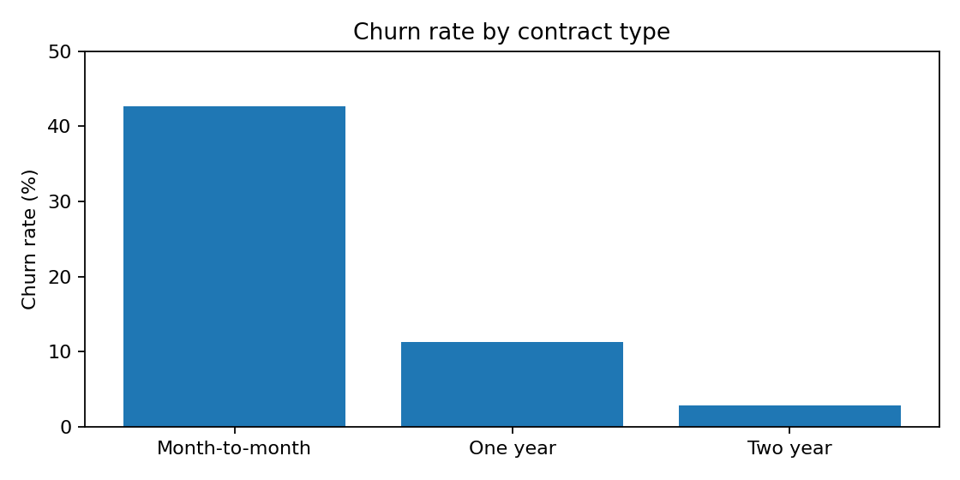
Figure 1. Churn rate by contract type, calculated from the supplied customer records.
The month-to-month segment has a 42.7% churn rate, compared with 11.3% for one-year contracts and 2.8% for two-year contracts. Month-to-month churn is approximately 15 times the two-year rate. This large descriptive gap makes contract type a strong candidate for segmentation in retention planning.
Recommended action: test a transparent upgrade offer for eligible month-to-month customers, but evaluate margin, discount cost, customer consent and whether customers would have stayed without the incentive.

Detailed explanation and project context
The first chart translates the contract query into a visual comparison. A bar chart is appropriate because contract is categorical and churn rate is a numeric measure. The axis should explicitly say “Churn rate (%)”, and the category labels should be readable without relying on colour alone. Data labels make the size of the differences easy to interpret. The figure is generated from the supplied CSV and is therefore reproducible from the same calculation. A reader should not interpret the chart as a time trend: the contract categories are not ordered time points. The accompanying text explains both the result and its business relevance, in accordance with the faculty instruction not to include screenshots or figures without commentary.

Python analytics: chart 2

7.3 Chart 2: churn by internet service
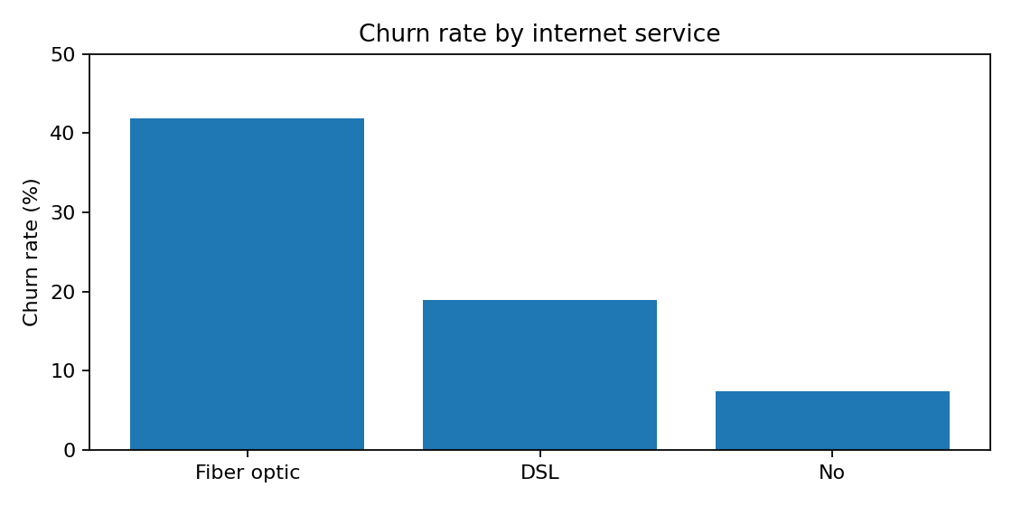
Figure 2. Churn rate by internet service category.
Fiber-optic customers have a 41.9% churn rate, compared with 19.0% for DSL and 7.4% for customers with no internet service. The high fiber-optic rate may reflect price, service expectations, acquisition mix or unobserved service issues. The dataset alone cannot distinguish among these explanations.
Recommended action: combine churn findings with network reliability, speed complaints, plan price, service tickets and customer tenure before selecting a service intervention.

Detailed explanation and project context
The internet-service chart highlights a segment that merits operational investigation. Fiber optic has the highest observed rate in this comparison, but the chart alone does not reveal whether customers are dissatisfied with reliability, price, speed, installation or another factor. It is important to separate the measured fact from a possible explanation. A next analytical step would compare complaint rates and service incidents by internet type, then adjust for tenure and contract. If the company introduces a quality improvement or communication intervention, results should be monitored before and after and, where feasible, against a comparable control group. The chart is a diagnostic signal, not a complete root-cause analysis.

Python analytics: chart 3

7.4 Chart 3: churn by tenure
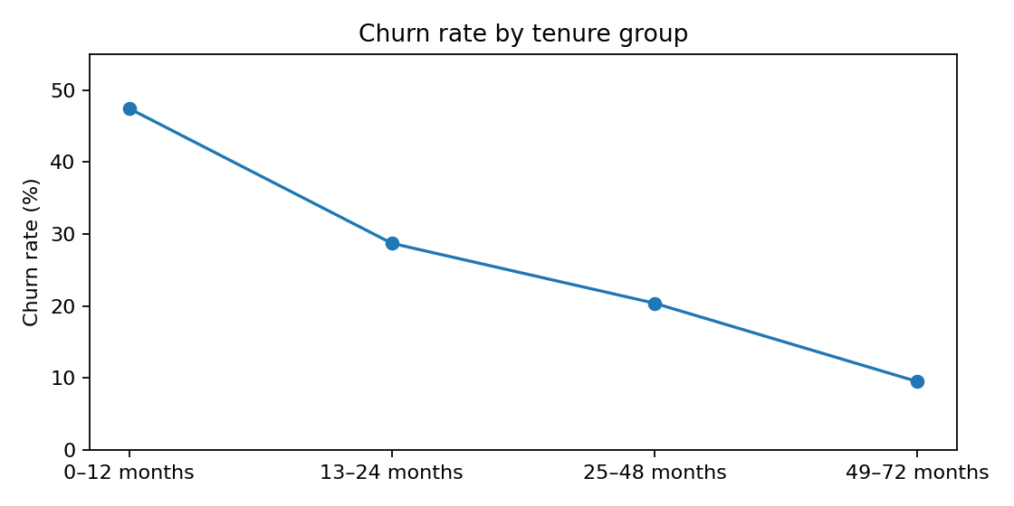
Figure 3. Churn rate by customer tenure band.
The highest rate occurs in the first 12 months (47.4%). It falls to 28.7% for months 13–24, 20.4% for months 25–48 and 9.5% for months 49–72. This pattern supports a focus on onboarding and early-life customer experience.
Recommended action: establish welcome communications, proactive setup checks, early bill explanations and support follow-ups. A/B testing should be used to estimate the incremental impact rather than assuming the programme will work.

Detailed explanation and project context
The tenure chart uses four ordered bands to make the pattern easy to read. The rate declines as tenure increases, from 47.4% in the first year to 9.5% among customers with 49–72 months of tenure. Grouping makes the chart understandable, but it also hides differences within each band. For example, customers in month one and month twelve are treated as one group even though their experiences may differ. If event dates and monthly snapshots become available, a cohort or survival analysis could examine when churn occurs more precisely. For the current project, the grouped chart supports a practical onboarding hypothesis: improve the early customer journey and measure whether the intervention changes retention.

Databricks and Delta Lake: architecture

8. Databricks and Delta Lake
The supplied notebook starts a SparkSession in local mode, reads telco.csv with header and inferred schema, counts records, prints the schema and displays sample rows. It then calculates churn by contract, overall KPIs and summaries for contract, internet service, payment method and SeniorCitizen.
The provided Databricks dashboard JSON defines a dataset called Customer Churn Metrics and measures for row count, average monthly charges, average tenure, churned count and churn rate. The dashboard includes counters, churn distribution, customers by contract, internet service and payment method, and a summary table.

Delta Lake concept
Delta Lake is a storage layer that adds a transaction log and ACID transaction support to data files and integrates with Spark. Databricks documents Delta Lake as a foundation for lakehouse tables and schema validation on write [2][3]. The supplied evidence confirms a Databricks dashboard, but does not by itself prove that a Delta table was created. That should be verified in the workspace before claiming it as a completed implementation.

Detailed explanation and project context
The Databricks and Delta Lake discussion should distinguish the technology used from the architecture proposed. The supplied notebook contains PySpark operations and the dashboard JSON documents a dashboard built over a customer churn dataset. Delta Lake is a table/storage layer commonly used with Spark, but the presence of a Databricks dashboard does not prove that a Delta table was created. The final report therefore describes Delta Lake as an architectural concept and recommends verifying the catalog and table format before stating it was implemented. This is important academically because tool names should not be treated as evidence of completed functionality. Screenshots of the workspace, table properties and successful reads from the Delta table would provide stronger evidence.

Databricks: processing steps and outputs

8.1 Spark processing workflow
- Create a Spark session for the telecom churn application.
- Read the CSV with header enabled and schema inference.
- Count records and inspect the inferred schema.
- Cast MonthlyCharges and TotalCharges to numeric types where needed.
- Aggregate counts and churned customers by segment.
- Calculate churn rate as churned customers / total customers × 100.
- Use the output for dashboard metrics and validation.

Example PySpark transformation
from pyspark.sql import functions as F

segment_summary = (
spark_df.groupBy('Contract')
.agg(
F.count('*').alias('Total_Customers'),
F.sum(F.when(F.col('Churn') == 'Yes', 1).otherwise(0)).alias('Churned_Customers')
)
.withColumn('Churn_Rate_Percent',
F.round(F.col('Churned_Customers') / F.col('Total_Customers') * 100, 2))
)
The transformation is scalable in concept, although the supplied dataset contains only 7,043 rows. Distributed processing is demonstrated as a tool workflow, not proven necessary for this small dataset.
Figures 4 and 5 are screenshots of the saved PySpark segment outputs in Bigdata_python_by_khush.ipynb, listing total customers, churned customers and churn rate for each segment.
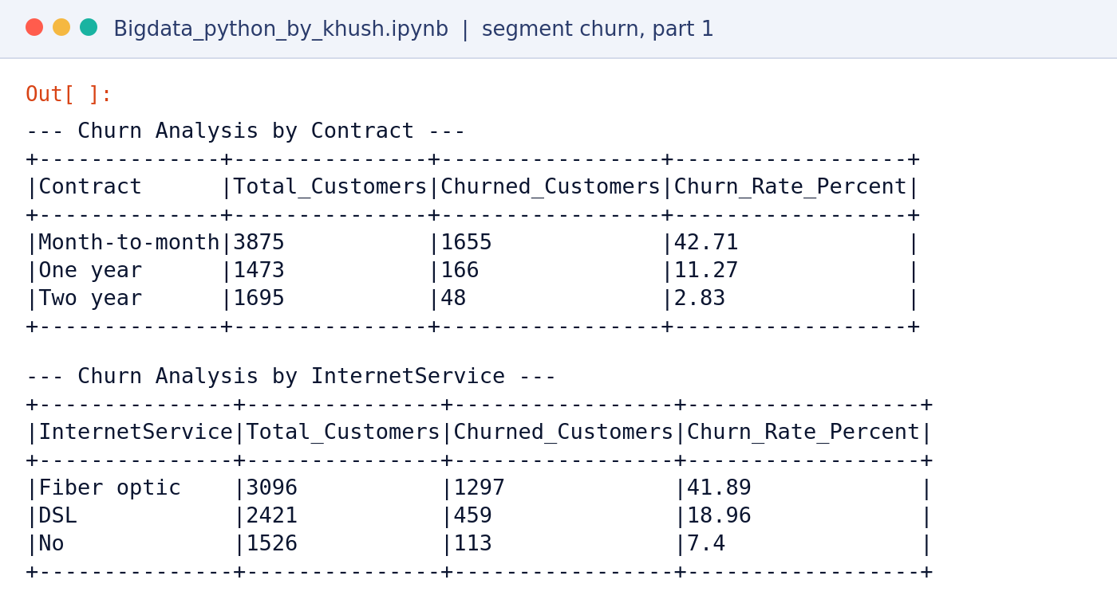
Figure 4. Saved notebook output: PySpark churn by contract and by internet service.
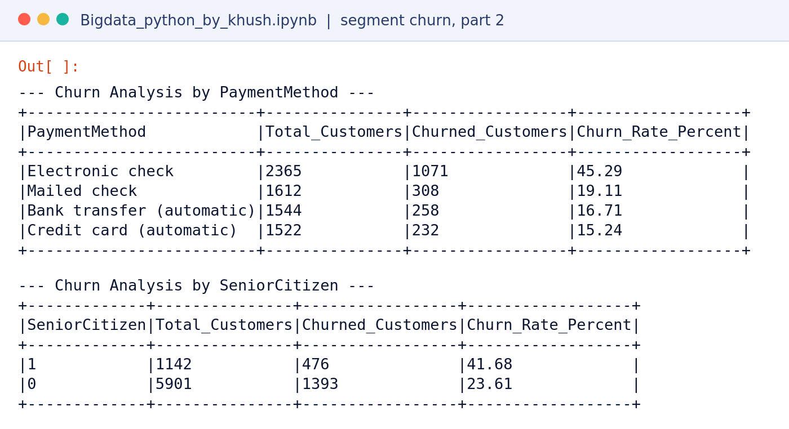
Figure 5. Saved notebook output: PySpark churn by payment method and by senior-citizen indicator.
These results agree with the SQL results to one decimal place (for example 42.71% against 42.7% for month-to-month contracts). The notebook also checks the SeniorCitizen indicator: 476 of 1,142 senior citizens churned (41.68%) compared with 1,393 of 5,901 other customers (23.61%). This is a descriptive association, not evidence that age causes churn.

Detailed explanation and project context
The Spark code groups records by contract and calculates total customers, churned customers and churn percentage. The same pattern can be reused for internet service, payment method and other categorical dimensions. Spark DataFrames express transformations as a sequence of operations that Spark can optimise when the action is executed. In the supplied notebook, count and show are used to inspect outputs. The data is relatively small, so local pandas would be sufficient for performance; the educational value is demonstrating how the same logic can be expressed in Spark and transferred to larger datasets. Scalability claims should remain measured: this dataset demonstrates a pipeline pattern, not a benchmark proving that distributed processing is faster for this workload.

Power BI dashboard and insights: design

9. Power BI dashboard
The presentation states that Power BI Desktop connected to PostgreSQL and was used to build a churn measure, KPI card and charts. The supplied PBIX file contains four report pages, each with one visual: a clustered bar chart of churn rate by contract type, a pie chart of the customer churn split, a donut chart of the share of customers by contract type, and a line chart of churn rate by tenure group.
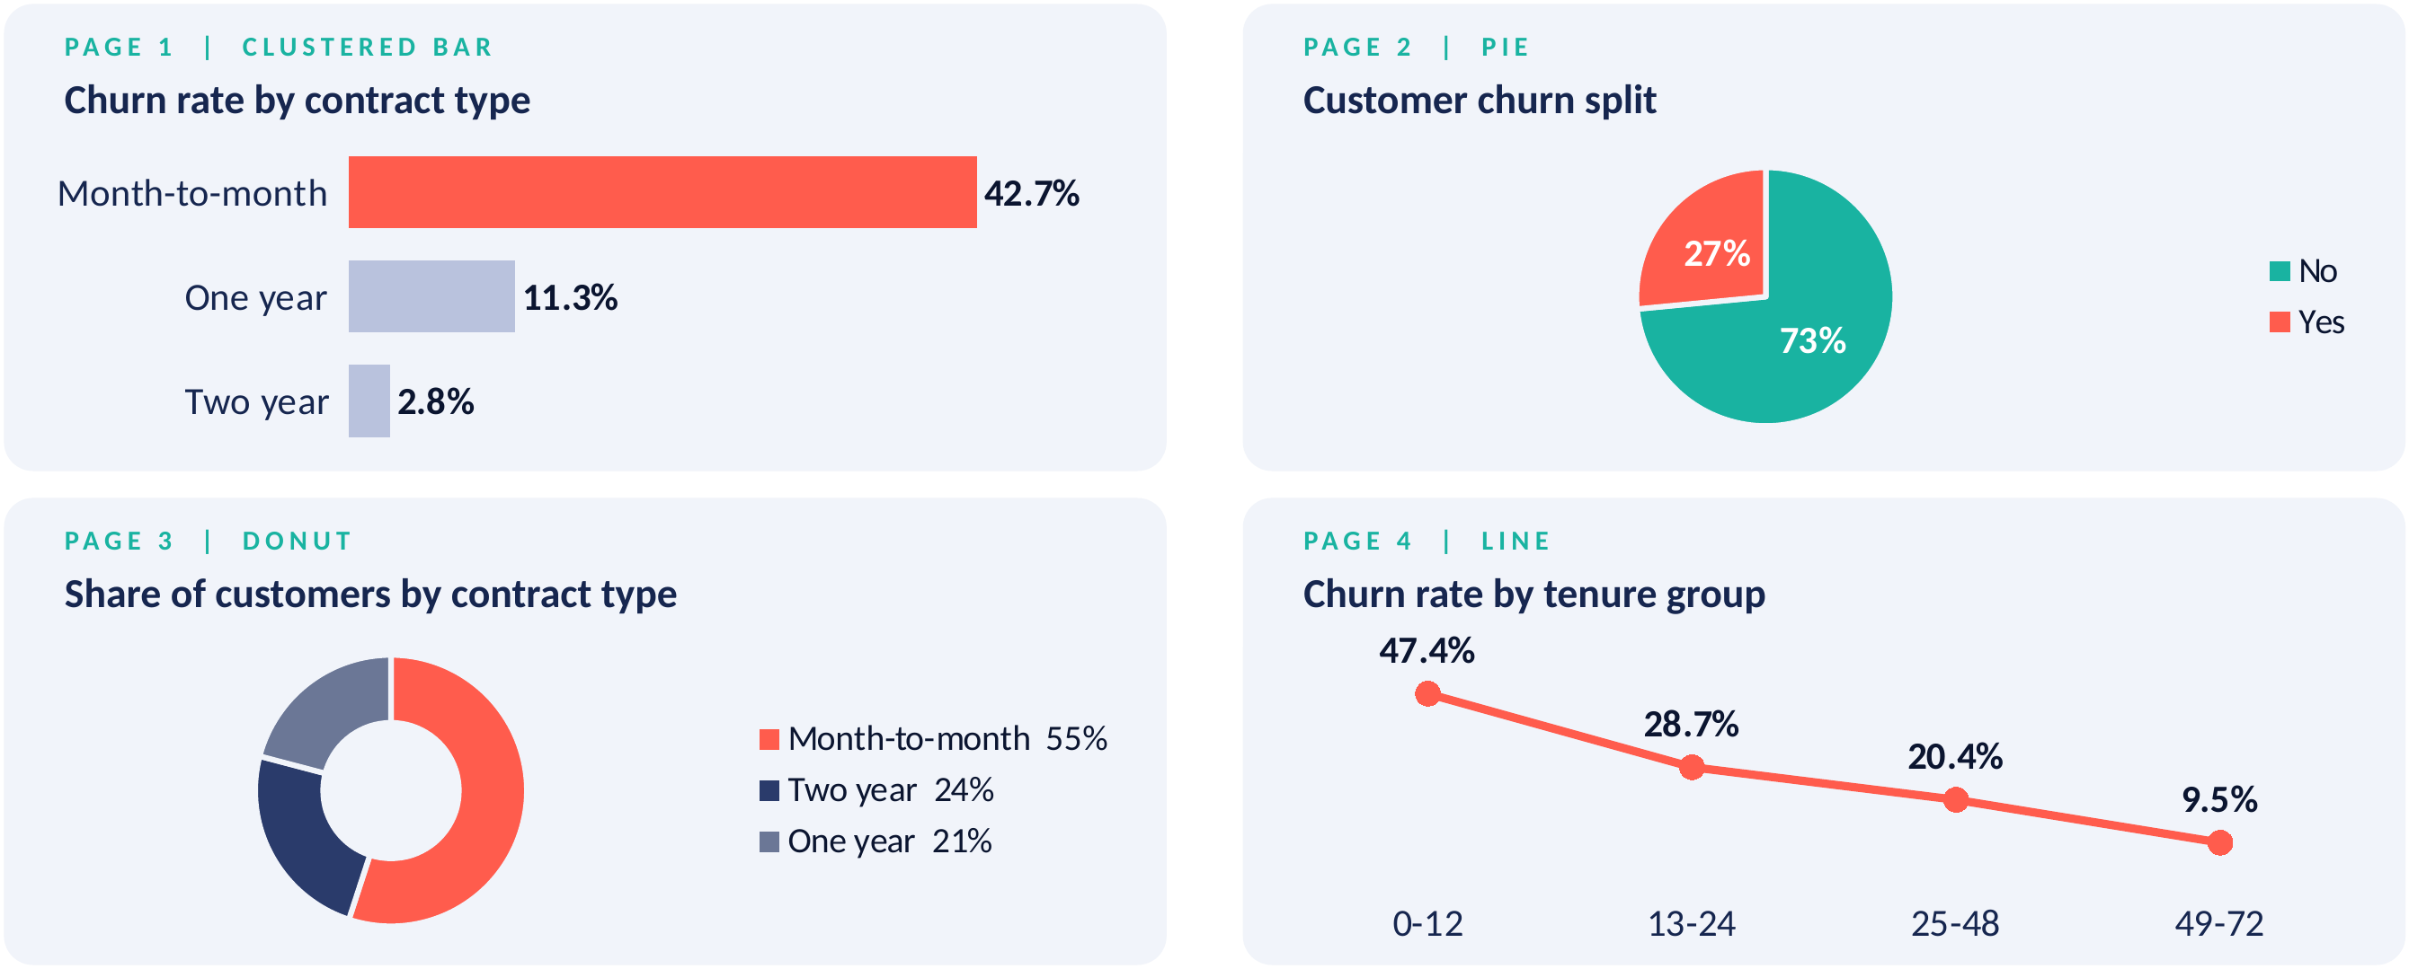
Figure 6. The four Power BI report pages, redrawn from the visual definitions in churn_analysis_by_khush.pbix. This illustrates the dashboard design and is not a Power BI screen capture.
Together the pages show the 26.54% baseline (pie), that 55% of customers hold month-to-month contracts (donut), and the contract and tenure gaps discussed earlier (bar and line). Because the PBIX data model opens only in Power BI Desktop, the figure was redrawn from the visual types and titles in the file and the segment results in this report; Desktop screenshots can replace it if required.

Suggested dashboard layout
- KPI cards: total customers, churned customers, churn rate and average monthly charges.
- Bar chart: churn rate by contract type.
- Bar chart: churn rate by internet service.
- Bar chart: churn rate by payment method.
- Bar chart or line chart: churn rate by tenure group.
- Comparison chart: churn rate by tech-support status.
- Slicers: contract, internet service, payment method and churn status, where supported.
Microsoft's Power BI guidance explains that visuals turn curated data and calculations into insights, and that filters and slicers support interactive exploration [4]. Use clear titles, units, data labels and consistent definitions across visuals.

Detailed explanation and project context
The Power BI dashboard is intended to turn query outputs into a management view. The main page should answer four questions quickly: how many customers are represented, how many churned, what proportion churned, and which segments show elevated rates? KPI cards provide context, while bar charts compare groups. Slicers can allow a reviewer to inspect contract, internet service, payment method or other available dimensions. The report should use consistent definitions between SQL and DAX. For example, the churn-rate measure must divide churned customers by the total number of customers remaining after the active filter context. A visual should include a clear title, a unit, sensible sorting and sufficient contrast. The dashboard screenshots accompanying this report should be taken from the actual PBIX file so that the evidence matches the implemented dashboard.

Power BI: measures and visual interpretation

9.1 KPI definitions
KPI | Definition | Use
Total customers | COUNTROWS(telco) | Denominator and coverage.
Churned customers | Count rows where Churn = Yes | Volume of customer loss.
Churn rate | Churned customers / total customers | Comparable measure of churn.
Average monthly charges | Average of MonthlyCharges | Revenue proxy, not total revenue.
Average tenure | Average of tenure | Relationship maturity baseline.

Example DAX measures
Total Customers = COUNTROWS(telco)
Churned Customers = CALCULATE(COUNTROWS(telco), telco[Churn] = "Yes")
Churn Rate = DIVIDE([Churned Customers], [Total Customers], 0)
Format Churn Rate as a percentage. If the model uses relationships or separate dimension tables, adapt the measure to the actual model. A measure should be validated against the source counts before it is used in decision-making.

Detailed explanation and project context
KPI measures should be defined once and reused consistently. Total customers is a row count under the current filters. Churned customers counts rows where Churn equals Yes. Churn rate divides the churned count by total customers and should be formatted as a percentage. Average monthly charges is a mean of the MonthlyCharges field and should not be labelled total revenue. Average tenure is a mean number of months and is not the same as customer lifetime. DAX measures respond to filter context, so slicers can change their values. Validate each card against a SQL query using the same filter conditions. If the dashboard has a different denominator or excludes missing values inconsistently, apparently small discrepancies may confuse users and weaken trust in the analysis.

Power BI: business insights

9.2 Dashboard insights
A dashboard is useful when each visual answers a decision question. Total-customer and churn-rate cards communicate the overall scale of the problem. Contract and tenure visuals help identify customer groups for retention journeys. Internet-service and support visuals can inform operational investigations. Payment-method analysis can help the billing team review friction and payment experience.

Interpretation principles
- Always show the denominator or customer count alongside a rate where possible.
- Do not compare raw churned counts as if they were rates.
- Keep category names consistent between SQL, Python, Databricks and Power BI.
- Avoid implying that a segment attribute causes churn.
- Check filters and totals after interacting with slicers.
The published Databricks dashboard link supplied with the project is: https://dbc-bdfe2a38-3fcb.cloud.databricks.com/dashboardsv3/01f1d123abc11ec08a504956443ae4f4/published?o=7474660548477223. Access may depend on workspace permissions and the dashboard's publication settings.

Detailed explanation and project context
The dashboard is most valuable when it leads to a decision or a follow-up question. A high rate by contract type can guide contract-offer testing; high first-year churn can guide onboarding improvements; a high rate by internet type can trigger service-quality investigation; and payment-method differences can motivate a billing-journey review. These are hypotheses for action rather than proof of causes. A good dashboard should help users ask the next question, not simply display a red bar. Provide counts with rates, make filters obvious, and note that the data is a snapshot. The published dashboard URL may require workspace access. Screenshots or exported evidence are provided so that the faculty can inspect the results without relying only on an external login.

Integration and validation

10. Integration and validation
Integration means the outputs from the different tools use the same source definition and comparable calculations. PostgreSQL and Databricks were both loaded from the CSV, while Python was used for cleaning and profiling. Power BI is documented as connected to PostgreSQL.

Validation checklist
Check | Expected / observed evidence | Status
Source row count | 7,043 rows | Verified from CSV and presentation.
Churn outcome count | 5,174 No; 1,869 Yes | Verified.
Overall churn rate | 26.54% | Verified.
Full-row duplicates | 0 in pandas full-row check | Verified.
TotalCharges blanks | 11 after numeric conversion | Verified.
SQL segment rates | Match direct calculation from CSV to 1 decimal | Recalculated.
Databricks Delta table | Must verify in workspace catalog | Not confirmed by supplied evidence.
ML model performance | No training/evaluation output supplied | Not implemented / not evidenced.

For repeatable validation, compare the same filters, denominator rules and missing-value treatment across systems. If TotalCharges is cleaned differently, ensure that it does not unintentionally alter the churn denominator.

Detailed explanation and project context
Integration validation is the control point between analysis stages. The raw CSV, PostgreSQL table and Spark DataFrame should agree on the number of customer rows before cleaning. Churn counts should match the source totals. Segment rates should be recalculated using the same inclusion rules and rounded only at presentation time. The 11 unparseable TotalCharges values should be handled explicitly. A mismatch does not automatically mean that one tool is wrong; it may result from a filter, a duplicate load, a different NULL treatment or a different grouping definition. Record the issue, trace it to the source and document the correction. This makes the pipeline auditable and provides a clear answer if a reviewer asks how a reported percentage was obtained.

Results and discussion: overall

11. Results and discussion
The overall churn rate is 26.54%, with 1,869 customers marked Yes. This is a substantial enough share to justify further investigation, but the dataset does not provide a financial value for each churn event or the cost of a retention intervention.

Main results
- Contract type has the largest observed spread among the analysed categories: 42.7% for month-to-month versus 2.8% for two-year contracts.
- The first-year tenure band has the highest tenure-group churn rate at 47.4%.
- Fiber-optic customers show 41.9% churn in the internet-service comparison.
- Electronic-check users show 45.3% churn in the payment-method comparison.
- Customers without tech support show 41.6% churn, compared with 15.2% among those with support.
These patterns provide a prioritisation framework. They should be combined with operational context and tested interventions before allocating a large retention budget.

Detailed explanation and project context
The overall rate of 26.54% provides the reference point for the segment findings. It means a little over one quarter of the customers in this dataset are marked as churned. The number is a descriptive statistic for this supplied sample, not necessarily a current industry benchmark or a forecast of future churn. A business decision also requires an estimate of the value at risk: monthly charges alone do not establish profit, because service costs, discounts and customer lifetime differ. The dataset does not contain a direct churn-reason field or a contribution-margin field. Therefore, the strongest defensible conclusion is that churn is concentrated in particular observed segments and should be investigated using additional operational and commercial data.

Concentration of churn in key segments
Segment | Customers | Share of base | Churned | Share of all churners
Month-to-month contract | 3,875 | 55.0% | 1,655 | 88.6%
Fiber optic internet | 3,096 | 44.0% | 1,297 | 69.4%
Electronic check payment | 2,365 | 33.6% | 1,071 | 57.3%

The segments overlap, so these shares must not be added together. They do show that a small number of identifiable groups account for most observed churn.

Results and discussion: business implications

11.1 Business implications

Marketing
Marketing can design segment-specific retention messages instead of generic promotions. Contract flexibility, early tenure and service bundle can inform the timing and content of outreach. Offers should be designed with clear eligibility rules and tracked for incremental retention.

Customer experience and service operations
The fiber-optic pattern should be investigated alongside network quality, installation experience, complaint volume and plan value. Support teams can review whether customers understand available technical assistance and whether support is easy to access.

Billing and payments
The electronic-check association warrants a review of payment journeys, billing communication and payment-method mix. It is not evidence that electronic checks cause churn. The business should test whether alternative payment options improve convenience without disadvantaging customers.

Commercial discipline
Retention should be measured in terms of incremental retained customers, contribution margin, discount cost, customer lifetime value and customer satisfaction—not churn rate alone.

Detailed explanation and project context
Marketing implications include personalising communications, clarifying plan benefits and testing offers that match customer needs. Service implications include checking installation and network performance, especially where a service category has an elevated churn rate. Billing implications include reviewing payment instructions, failed-payment processes and clarity of bills. Support implications include checking whether customers know how to get help and whether support access is easy. Each action should have an owner, a measurable outcome and a time horizon. It is also important to monitor potential negative effects such as excessive discounting, unwanted contact or a rise in complaints. The project provides a shortlist of areas for investigation, but business teams should validate root causes before making large-scale changes.

Recommendations and implementation roadmap

12. Practical recommendations
Priority | Action | Rationale | Suggested owner
1 | Early-life onboarding programme | 0–12 month group has 47.4% churn. | Customer experience
2 | Contract upgrade experiments | Month-to-month group has 42.7% churn. | Marketing / pricing
3 | Fiber service deep-dive | Fiber group has 41.9% churn. | Network operations
4 | Payment journey review | Electronic-check group has 45.3% churn. | Billing / payments
5 | Tech-support awareness and access | No-support group has 41.6% churn. | Customer support
6 | Measurement framework | Determine incremental impact and cost. | Analytics / finance

The priorities are based on observed segment rates, not a causal model. Before targeting, check customer eligibility, contact permissions, product suitability and potential unintended consequences.

12.1 Suggested 90-day roadmap
Period | Activities | Deliverables
Weeks 1–2 | Validate source, definitions, dashboards and segment counts. | Signed-off baseline.
Weeks 3–4 | Review complaints, service tickets, pricing and billing for priority segments. | Root-cause hypotheses.
Weeks 5–8 | Pilot onboarding/support interventions and contract messaging with a control group. | Experiment monitoring.
Weeks 9–10 | Evaluate churn, margin, engagement and complaints by treatment/control. | Experiment readout.
Weeks 11–12 | Scale only interventions with credible incremental benefit. | Decision memo.

Success metrics should include churn at a defined horizon, incremental retention versus control, cost per retained customer, contribution margin and customer complaints.

Detailed explanation and project context
The retention plan prioritises actions based on observed churn rates and the practical ability to test interventions. Early-life onboarding is prioritised because the first-year group has the highest rate. Contract upgrade experiments are relevant because month-to-month customers show much higher churn than longer-contract groups. Fiber service is assigned to operational investigation rather than an automatic discount because the dataset does not identify the underlying cause. Payment-method review should focus on customer experience and convenience, not blame the payment choice. Tech-support promotion should ensure that the offer is relevant and accessible. The analytics team should define success measures before any pilot begins. Priorities can change once customer value, intervention cost and operational evidence are considered.

Conclusion, future improvements and individual contribution

13. Conclusion
The project demonstrates an end-to-end descriptive analytics workflow for telecom churn: source-file profiling, relational database loading, SQL segment analysis, Python cleaning, Spark aggregations, dashboard design and business interpretation.
The source dataset contains 7,043 customers and shows an overall churn rate of 26.54%. Contract type, tenure, internet service, payment method and tech support are useful dimensions for prioritising further investigation.

Future improvements
- Build a tested predictive churn model using a train/validation/test split and leakage-safe preprocessing.
- Evaluate recall, precision, F1, ROC-AUC and PR-AUC; calibrate probabilities if used for targeting.
- Add complaint, network quality, billing and contact-history features where permitted.
- Create a reproducible data-quality test suite and automated refresh pipeline.
- Use Delta tables with documented schema and data-quality checks if confirmed in the Databricks workspace.
- Add experiment tracking and calculate retention campaign economics.
The current evidence supports descriptive conclusions only. Predictive performance and causal campaign impact remain future work.

14. Individual contribution and learning
This was an individual project completed independently by the student. The student was responsible for planning the analysis, preparing and inspecting the dataset, developing SQL queries, carrying out Python-based profiling and cleaning, working with Spark/Databricks, preparing dashboard outputs, interpreting the results and compiling the report and presentation.

Skills developed
- Data profiling and data-quality checks.
- SQL aggregation and conditional calculations.
- Python/pandas data cleaning and descriptive analysis.
- Spark-based group-by transformations.
- Dashboard KPI design and visual interpretation.
- Translating analytical findings into practical business recommendations.

Detailed explanation and project context
A 90-day roadmap gives the project a realistic path from analysis to learning. The first two weeks should establish data definitions and validate the baseline. Weeks three and four can combine the churn findings with complaints, service tickets and pricing data to identify plausible causes. Weeks five through eight can run a controlled pilot, with clear eligibility rules and an appropriate comparison group. Weeks nine and ten should evaluate both retention and guardrail metrics. Weeks eleven and twelve should document whether to scale, modify or stop the intervention. The roadmap should not promise a specific reduction in churn before evidence exists. Its purpose is to make the next steps manageable, measurable and accountable.

Objectives and outcomes
Objective | Outcome
Profile the data and check quality | Completed: 7,043 rows, 0 duplicates, 11 blank TotalCharges values
Load and analyse in PostgreSQL | Completed: psql load and five segment-level SQL queries
Clean and convert TotalCharges | Completed in Python using coercion to missing values
Compare churn across segments | Completed for contract, internet, payment, tenure and tech support
Spark and Databricks workflow | Documented; Delta table to be verified in the workspace
Visuals and recommendations | Completed: charts, dashboard design and prioritised actions

Key takeaways
- Churn is concentrated in early-tenure, month-to-month, fiber-optic and electronic-check customers.
- The evidence is descriptive; prediction and causal impact are future work.
- A small, controlled pilot is the recommended next step before any large investment.

Closing remarks
The project shows how a single customer dataset can move through a relational database, a scripting environment, a distributed processing workflow and a business intelligence layer while keeping definitions consistent. Its main value lies in the transparent baseline and the clearly stated limits of the evidence. With complaint history, pricing data and a controlled pilot, the same pipeline can be extended from describing churn to predicting it and, ultimately, to reducing it in a measurable way.
Finally, the report deliberately separates what was measured from what was only proposed. The segment rates, counts and data-quality findings are measured results; the Delta Lake table, the predictive model and the retention programme are proposals that require further evidence. Keeping this distinction visible allows the reader to trust the conclusions that are made and to see clearly where further work is needed.

References and supporting evidence: references

15. References
Project artefacts supplied by the student
- telco.csv — source dataset supplied for this project.
- Bigdata_python_by_khush.ipynb — Python and PySpark notebook.
- customer churn rate by khush.sql — five SQL segment-analysis queries.
- churn_analysis by khush.pbix — Power BI report file supplied for review.
- Customer Churn Analysis 2026-10-26 15_27_35.lvdash.json — Databricks dashboard configuration.
- Churn_Analysis_Verified_11_Slides.pptx — project presentation and documented findings.
External technical references
[1] PostgreSQL Global Development Group. “COPY.” PostgreSQL documentation. https://www.postgresql.org/docs/18/sql-copy.html
[2] Databricks. “What is Delta Lake?” Databricks documentation. https://docs.databricks.com/aws/en/delta/
[3] Databricks. “Schema enforcement.” Databricks documentation. https://docs.databricks.com/aws/en/tables/schema-enforcement
[4] Microsoft Learn. “Overview of visualizations in Power BI.” https://learn.microsoft.com/en-us/power-bi/visuals/power-bi-visualizations-overview

Detailed explanation and project context
The project meets its descriptive objective by documenting a repeatable pipeline and explaining the main segment-level patterns. It provides a baseline for future analysis and a set of actionable hypotheses. The strongest limitation is that the current evidence does not include a trained and evaluated machine-learning model, customer event history or a causal experiment. A future model should be built only after defining when a prediction is made and what future period it covers. It should use leakage-safe preprocessing and appropriate evaluation metrics. A future experiment should measure incremental retention and financial impact. The conclusion is therefore balanced: the project has produced useful descriptive insights, while prediction and causal impact remain opportunities for further development.

Supporting evidence and appendix

Appendix A. Selected SQL pattern
SELECT paymentmethod, COUNT(*) AS customers,
ROUND(100.0 * SUM(CASE WHEN churn='Yes' THEN 1 ELSE 0 END) / COUNT(*), 1) AS churn_pct
FROM telco
GROUP BY paymentmethod
ORDER BY churn_pct DESC;

Appendix B. Python cleaning pattern
df = pd.read_csv('telco.csv')
df = df.drop_duplicates()
df.columns = df.columns.str.strip()
for col in df.select_dtypes(include='object').columns:
df[col] = df[col].str.strip()
df['TotalCharges'] = pd.to_numeric(df['TotalCharges'], errors='coerce')
df_clean = df.dropna(subset=['TotalCharges']).copy()

Appendix C. Supporting evidence checklist
- Screenshot of PostgreSQL telco table and row count.
- DBeaver result grids for all five SQL queries.
- Notebook outputs showing shape, missing TotalCharges and segment calculations.
- Databricks published dashboard screenshot with date/access context.
- Power BI report screenshots with filters and metric definitions.
- GitHub repository URL containing complete scripts/notebook, if used.
Do not include passwords, tokens, API keys or private customer data in screenshots or repository files.

Detailed explanation and project context
This project was completed by Khush Talera independently as an individual project. There were no team members or shared team contributions. The student independently undertook the project planning, dataset inspection, SQL analysis, Python-based data profiling and cleaning, Spark/Databricks work, dashboard preparation, interpretation of findings, report writing and presentation preparation, to the extent evidenced by the submitted project artefacts.
Project type: Individual project (completed independently)

